
SCHOOL OF ENGINEERING
Department of Artificial Intelligence and Machine Learning
CERTIFICATE
This is to certify that the DBMS Capstone project work entitled “SMART UNIVERSITY ACADEMIC MANAGEMENT SYSTEM” is a bona fide record of work carried out and submitted by
L. AMRUTHA 26B21AI063
K. GEETHA 26B21AI107
B. CHANDINI 26B21AI015
S. BHUVANA 26B21AI106
in partial fulfilment of the requirements for the award of the degree of Bachelor of Technology in Artificial Intelligence and Machine Learning during the academic year 2026–2027.
Project Guide  Ms. M. Pravallika,MCA, M.Tech  Assistant Professor  Department of AIML | Head of the Department  Dr. K.Naga bhargavi, M.Tech, Ph.D  Associate Professor  Department of AIML

Internal Examiner External Examiner

DECLARATION
We hereby declare that the DBMS Capstone project entitled “SMART UNIVERSITY ACADEMIC MANAGEMENT SYSTEM” is an original piece of work carried out by us and is submitted to ADITYA UNIVERSITY, Surampalem, in partial fulfilment of the requirements for the award of the degree of Bachelor of Technology in Artificial Intelligence and Machine Learning.
We further declare that this project work has not been submitted, either in full or in part, for the award of any degree or diploma of this or any other institution. We also confirm that this work complies with the Institutional Academic Integrity and AI Usage Policy of Aditya University.
Place: Surampalem
Date: ______________
Project Associate:
L. AMRUTHA 26B21AI063
K. GEETHA 26B21AI107
B. CHANDINI 26B21AI015
S. BHUVANA 26B21AI106

ACKNOWLEDGEMENT
It is with immense pleasure that we express our sincere gratitude to our Cornerstone Project Guide, Ms. M. Pravallika, Assistant Professor, who has guided us throughout the project. Her valuable support, encouragement, and guidance have greatly contributed to the successful completion of this work.

We would like to thank our Deputy Heads of the Department, Dr. R. Suneetha, Assistant Professor, Dr.Bollu Manikyala Rao, Associate Professor ,Dr.D.Veeraswamy,Assistant Professor Department of AIML, for their support and valuable suggestions.

Our deepest thanks to our Head of the Department Dr. . K.Naga bargavi, Associate Professor,
for her inspiration and for providing all the necessary facilities and resources required for this project.

We also extend our sincere thanks to Dr. M.V. Rajesh, Associate Dean, School of Computing for their encouragement and support during the course of our project.

We would like to express our sincere gratitude to Dr. G. Suresh, Registrar, Dr. A Ramesh, Pro Vice-Chancellor (Engineering & Sciences), Dr.S. Rama S r e e , Pro Vice-Chancellor (Academics), D r . M.B. Srinivas, V i c e -Chancellor, Dr. M. Sreenivasa Reddy, Deputy Pro Chancellor and Management, Aditya University for providing excellent infrastructure and state-of-the-art laboratories.

Finally, we would like to thank the faculty members, lab technicians, non-teaching staff, and our friends who have directly or indirectly supported us in completing this Cornerstone project successfull
ABSTRACT
The Smart University Academic Management System is a centralized relational database designed to manage and organize the academic activities and records of a university in a structured and reliable manner. The system integrates major academic entities including Department, Student, Faculty, Course, Enrolment, Attendance, Examination, Result, Placement, Scholarship, Student Scholarship, Performance History, and Result Audit. These entities are connected through well-defined primary key and foreign key relationships, with constraints such as PRIMARY KEY, FOREIGN KEY, NOT NULL, UNIQUE, CHECK, DEFAULT, and AUTO_INCREMENT used to maintain data integrity and consistency. The database is designed using an Entity-Relationship model and implemented in MySQL with a normalized relational structure to reduce redundancy and avoid data anomalies. The system manages student enrolment, course details, attendance records, examination results, academic performance, scholarships, and placement information within a centralized database. A generated column automatically calculates attendance percentage, while a trigger automatically determines student grades and result status based on marks obtained. Additional database functionality is provided through stored functions for academic risk assessment and placement eligibility, views for academic risk, placement eligibility, student academic summaries, and department performance, and stored procedures for generating student reports and identifying at-risk students. A result auditing mechanism records changes made to examination results, while indexes are implemented to improve query performance on frequently accessed data. The system therefore provides an organized and consistent platform for academic data management, supports efficient information retrieval and analysis, reduces redundancy, and assists in identifying academic risks and placement eligibility. The project also provides a foundation for future enhancements such as web-based interfaces, role-based access control, automated notifications, advanced analytics, and cloud-based deployment.

Keywords: Smart University Academic Management System, Student Management, Course Management, Enrolment, Attendance Management, Examination and Result Management, Academic Risk Assessment, Placement Eligibility, Scholarship Management, Performance History, Result Auditing, MySQL, Relational Database, SQL, Database Normalization
LIST OF CONTENTS
CONTENTS | PAGE NO
Certificate | i
Declaration | ii
Acknowledgement | iii
Abstract  List Of Contents | iv  v-vi
List of Figures  List of Tables | vii  viii
Chapter 1: Introduction | 1-2
1.1 Introduction | 1
1.2 Problem Statement | 1
1.3 Objectives of the Project | 1-2
1.4 Scope of the Project | 2
Chapter 2: System Overview | 3-4
2.1 Existing System | 3
2.2 Limitations of Existing System | 3
2.3 Proposed System | 3
2.4 Software Requirements | 4
2.5 Hardware Requirements | 4
Chapter 3: System Implementation | 5-6
3.1 Overview of Development Tools | 5
3.1.1 MySQL | 5
3.1.2 MySQL Workbench | 6
Chapter 4: System Architecture | 7-8
Chapter 5: Database Design and Normalization | 9-17
5.1 Introduction | 9
5.2 Entity Identification | 9
5.3 Attributes and Relationships | 10-12
5.4 ER Diagram | 12-13
5.5 Relational Schema | 13-14
5.6 Primary Keys and Foreign Keys | 14-15
5.7 Normalization | 15
5.8 First Normal Form (1NF) | 15
5.9 Second Normal Form (2NF) | 15-16
5.10 Third Normal Form (3NF) | 16
5.11 Data Integrity and Constraints | 16-17
5.12 Summary | 17
Chapter 6: SQL Operations and Queries | 18-30
6.1 Introduction | 18
6.2 Database and Table Creation | 18-22
6.3 Data Insertion | 22-23
6.4 Data Retrieval | 23-24
6.5 Data Modification | 24
6.6 Data Deletion | 25
6.7 Joins | 25-27
6.8 Aggregate Functions | 27-28
6.9 Subqueries | 28-29
6.10 Views | 30
Chapter 7: Results and Analysis | 31-34
7.1 Introduction | 31
7.2 Database Implementation | 31
7.3 Table Creation and Data Insertion | 31
7.4 SQL Query Results | 32
7.5 Relationship Analysis | 32-33
7.6 Constraint Validation | 33
7.7 Key Findings | 33-34
Chapter 8: Output Screens | 35-41
Conclusion | 42
Future Scope | 43
References | 44

LIST OF FIGURES

Figure No. | Title of Figure | Page No
Fig. 4.1 | System Architecture of the Smart University Academic Management System | 7
Fig. 5.1 | Entity-Relationship (ER) Diagram of the Smart University Academic Management System | 12
Fig. 8.1 | MySQL Database Creation | 35
Fig. 8.2 | Department, Student and Faculty Tables | 35-36
Fig. 8.3 | Course and Enrolment Tables | 36
Fig. 8.4 | Attendance and Examination Tables | 37
Fig. 8.5 | Result and Placement Tables | 37-38
Fig. 8.6 | Scholarship and Student Scholarship Tables | 38
Fig. 8.7 | Performance History and Result Audit Tables | 38-39
Fig. 8.8 | Sample SQL Query Output | 39
Fig. 8.9 | JOIN Query Output | 39
Fig. 8.10 | Aggregate Query Output | 40
Fig. 8.11 | Academic Risk Report Output | 40
Fig. 8.12 | Placement Eligibility Report Output | 40
Fig. 8.13 | Student Academic Summary Output | 41
Fig. 8.14 |  | 41
  Department Performance Output

LIST OF TABLES

Table No | Title of the Tables | Page No
Table 2.1 | Software Requirements | 4
Table 5.1 | Entity Identification | 9-10
Table 5.1 | Attribute Types | 10
Table 5.1 | Key Attributes of Core Entities | 10-11
Table 5.1 | Primary Keys and Foreign Keys | 14-15

CHAPTER 1 - INTRODUCTION

1.1 Introduction

The Smart University Academic Management System is a MySQL-based relational database designed to manage and organize university academic information in a centralized manner. The system maintains data related to departments, students, faculty, courses, enrolments, attendance, examinations, results, placements, scholarships, and academic performance. Primary keys, foreign keys, and constraints are used to maintain data accuracy and relationships between tables. The system also uses SQL triggers, functions, views, and stored procedures to automate result processing, academic risk assessment, placement eligibility, and student reporting. This provides a structured and efficient way to store, manage, and retrieve academic information.

1.2 Problem Statement

Universities handle large amounts of academic data such as student details, courses, attendance, examinations, results, scholarships, and placements. Managing this information without a centralized database can lead to data duplication, inconsistency, and difficulty in retrieving required information. It may also be difficult to identify students at academic risk and determine placement eligibility efficiently. Therefore, a centralized relational database system is required to organize academic data, maintain relationships between records, and provide accurate information for academic management.

1.3 Objectives of the Project

The main objectives of the Smart University Academic Management System are:

To design a centralized database for managing university academic information.

To store and manage student, faculty, department, course, and enrolment details.

To maintain attendance, examination, result, placement, scholarship, and performance records.

To establish proper relationships using primary keys and foreign keys.

To maintain data accuracy using SQL constraints and triggers.

To calculate academic risk and placement eligibility using database functions.

To provide useful academic information through views and stored procedures.

To maintain an audit record of result updates.

1.4 Scope of the Project
The Smart University Academic Management System focuses on managing and organizing university academic data using a centralized MySQL database. The system covers student, department, faculty, course, enrolment, attendance, examination, result, placement, scholarship, and academic performance information. It supports data validation through constraints and automates result processing using triggers. The system also provides academic risk assessment, placement eligibility analysis, student reports, and result auditing through SQL functions, views, and stored procedures. The project is limited to the database management layer and can be further extended into a web or mobile-based application in the future.

CHAPTER 2 - SYSTEM OVERVIEW

2.1 Existing System

In many educational institutions, student academic information is maintained using separate registers, spreadsheets, or independent systems. Student details, course information, attendance, examination results, scholarships, and placement records may be stored separately. This makes it difficult to maintain consistent data and quickly retrieve complete academic information. Manual processing can also lead to data duplication, errors, and difficulty in generating academic reports.

2.2 Limitations of Existing System

Academic information is maintained in separate records.

Data duplication and inconsistency may occur.

Retrieving complete student academic information is time-consuming.

Manual attendance and result processing can lead to errors.

Identifying academically at-risk students is difficult.

Placement eligibility cannot be easily evaluated from combined academic data.

Generating reports from different records requires additional manual effort.

2.3 Proposed System

The proposed Smart University Academic Management System provides a centralized relational database for managing university academic information. The system stores department, student, faculty, course, enrolment, attendance, examination, result, placement, scholarship, and performance records in related tables.

Primary keys, foreign keys, and constraints are used to maintain data integrity. SQL triggers automatically calculate grades and result status. Functions are used for academic risk assessment and placement eligibility. Views and stored procedures provide useful reports and simplify data retrieval. The system therefore provides a structured and efficient database for managing academic information.

2.4 Software Requirements
Table. 2.1: Software Requirements
Software | Purpose
  Windows 10/11
  Operating system for development
  MySQL Server
  Database management system
  MySQL Workbench
  Database design, SQL execution, and administration
  dbdiagram.io
  Preparation of the ER diagram
  Microsoft Word
  Project documentation
  Microsoft PowerPoint
  Project presentation

2.5 Hardware Requirements
- Processor: Intel Core i3 or higher
- RAM: Minimum 4 GB; 8 GB recommended
- Storage: Minimum 250 GB
- System Type: 64-bit system
- Input/Output: Keyboard, mouse, and monitor

CHAPTER 3 - SYSTEM IMPLEMENTATION

3.1 Overview of Development Tools

The Smart University Academic Management System was designed and implemented using MySQL as the relational database management system and MySQL Workbench as the primary development environment. dbdiagram.io was used to prepare the ER diagram. These tools were used for database creation, table design, SQL query execution, relationship management, and database visualization.

3.1.1 MySQL

MySQL is a Relational Database Management System (RDBMS) that stores data in structured tables and manages relationships using primary and foreign keys. It supports SQL for creating tables, inserting and retrieving data, applying constraints, and managing database objects.

In this project, MySQL is used to store and manage university academic data such as departments, students, faculty, courses, enrollments, attendance, examinations, results, placements, scholarships, and performance history.

Supports PRIMARY KEY and FOREIGN KEY constraints for maintaining relationships.

Supports CHECK and UNIQUE constraints for data validation.

Provides triggers, functions, views, and stored procedures used in the project.

Supports indexes for efficient data retrieval.

Provides SQL operations for inserting, updating, deleting, and retrieving academic records.

3.1.2 MySQL Workbench
MySQL Workbench is a graphical database development and administration tool used with MySQL. It was used in this project for creating the database, executing SQL queries, managing tables, and verifying database relationships.
- Used to create and manage the smart university database.
- Used to create and modify tables, constraints, triggers, views, and procedures.
- Used to execute SQL queries and view their results.
- Used to reverse engineer the database and visualize its relationships.
- Used to verify the structure and contents of the database during implementation.

CHAPTER 4 - SYSTEM ARCHITECTURE
The architecture of the Smart University Academic Management System follows a layered flow that represents how different university users interact with the academic management system. At the top, the main user roles — Administrator, Department Head/HOD, Faculty Member, and Student — access academic functions according to their responsibilities. The academic management layer handles student information, course and enrolment management, attendance, examinations, academic progress, reporting, scholarships, and placement-related information.
Fig. 4.1: System Architecture of the Smart University Academic Management System
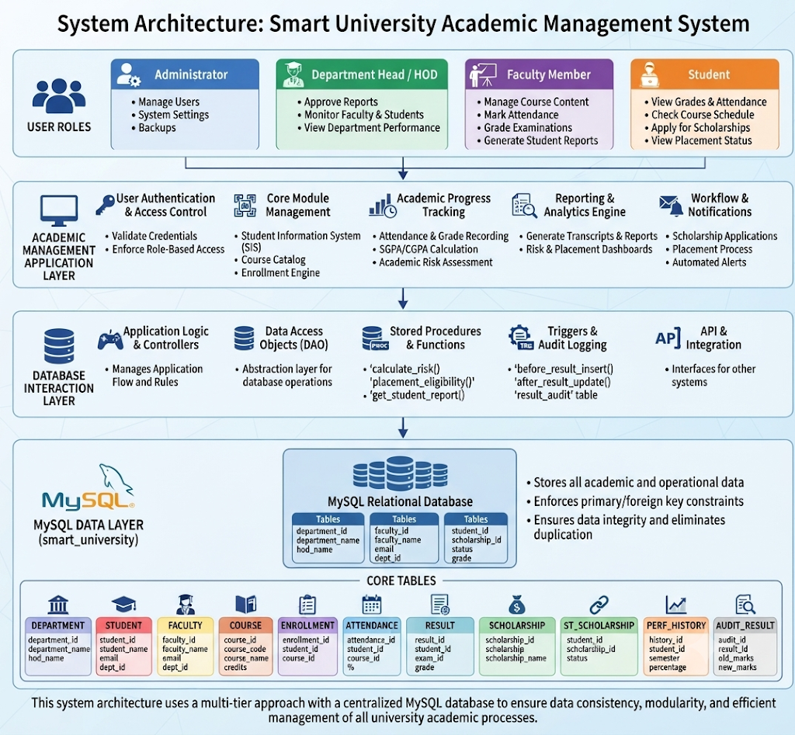
The overall flow of the architecture is represented below:
Users (Administrator / Department Head / Faculty Member / Student)
↓
Academic Management Application Layer
↓
Database Interaction Layer
↓
MySQL Relational Database (smart university)
↓
Department | Student | Faculty | Course | Enrolment | Attendance | Examination | Result | Placement | Scholarship | Performance History | Result Audit

Each component plays a distinct role in this flow:
• Users: Administrators manage system-related activities; Department Heads monitor faculty and student performance; Faculty Members manage courses, attendance, and examinations; Students view academic information, scholarships, and placement-related details.
• Application Layer: Represents the academic functions through which users interact with student information, courses, enrollment, attendance, examinations, reports, and other academic activities.
• Database Interaction Layer: Represents the processing and database operations required to manage academic records and apply the defined database functions, procedures, views, and triggers.
• Database Layer (MySQL): Stores academic information in related tables and maintains data integrity using primary keys, foreign keys, and other constraints.
• Data Layer: The core tables store department, student, faculty, course, enrollment, attendance, examination, result, placement, scholarship, performance history, and result audit information.
This architecture provides a centralized structure for managing university academic information. The relational database acts as the central data store, while the defined database features support academic processing, reporting, risk assessment, placement eligibility, and result auditing.

CHAPTER 5 DATABASE DESIGN AND NORMALIZATION

5.1 Introduction

Database design defines the structure of the Smart University Academic Management System by identifying entities, attributes, keys, and relationships. The database is designed using a relational model in MySQL to store academic information efficiently and maintain data integrity. The design also applies normalization principles to reduce data redundancy and avoid data inconsistencies.

5.2 Entity Identification
The following entities are identified in the Smart University Academic Management System:
Table. 5.1: Entity Identification
Entity | Purpose
  Department
  Stores department details such as department name, HOD, and office email.
  Student
  Stores student personal and academic information.
  Faculty
  Stores faculty details and department association.
  Course
  Stores course details, credits, semester, and assigned faculty.
  Enrolment
  Records student enrolment in courses.
  Attendance
  Stores student attendance details for each course.
  Examination
  Stores examination details and maximum marks.
  Result
  Stores marks, grades, and result status of students.
  Placement
  Stores student placement and company details.
Scholarship | Stores scholarship eligibility requirements.
Student Scholarship | Records student applied for by students.
Performance history | Stores semester-wise academic performance.
 | Maintains records of result updates for auditing.
  Result Audit

5.3 Attributes and Relationships
Each entity in the Smart University Academic Management System contains attributes that describe its academic information. Most attributes are simple and atomic. The system also contains a generated attribute and a composite key as part of its relational design.
Table. 5.: Attribute Types
Attribute Type | Description | Example (Patient entity)
Simple | A single, atomic value that cannot be meaningfully subdivided. | Student_name,email,gender
Composite | An attribute that can be broken down into smaller sub-attributes. | Student Scholarship: student id + scholarship id
Derived | A value that is computed from another stored attribute rather than stored directly. | Attendance_percentage
The complete attribute sets used for the core entities are as follows:
Table. 5.3: Key Attributes of Core Entities
Entity | Key Attributes
  Department
  department_id (PK), department_name, hod_name, office_email
  Student
  student_id (PK), student_name, gender, date_of_birth, phone, email, department_id (FK), admission_year, current_semester
  Faculty
  faculty_id (PK), faculty_name, email, phone, designation, department_id (FK)
  Course
  course_id (PK), course_code, course_name, credits, semester, department_id (FK), faculty_id (FK)
  Enrolment
  enrollment_id (PK), student_id (FK), course_id (FK), academic_year, semester, enrollment_date
  Attendance
  attendance_id (PK), student_id (FK), course_id (FK), classes_held, classes_attended, attendance_percentage (derived)
  Examination
  exam_id (PK), course_id (FK), exam_type, exam_date, maximum_marks
  Result
  result_id (PK), student_id (FK), exam_id (FK), marks_obtained, grade, result_status
  Placement
  placement_id (PK), student_id (FK), company_name, package_lpa, placement_status, placement_date
Scholarship | scholarship_id (PK), scholarship_name, minimum_percentage, maximum_income
Student Scholarship | student_id (PK, FK), scholarship_id (PK, FK), family_income, application_status
Performance history | history_id (PK), student_id (FK), academic_year, semester, semester_percentage
 | audit_id (PK), result_id, student_id, action_type, old_marks, new_marks, action_time
  Result Audit

The relationships between the entities are summarized below:

Department to Student: One-to-many — a department can have many students.

Department to Faculty: One-to-many — a department can have many faculty members.

Department to Course: One-to-many — a department can offer many courses.

Faculty to Course: One-to-many — a faculty member can be assigned to multiple courses.

Student to Enrollment: One-to-many — a student can enroll in multiple courses.

Course to Enrollment: One-to-many — a course can have multiple student enrollments.

Student to Attendance: One-to-many — a student can have attendance records for multiple courses.

Course to Attendance: One-to-many — a course can have attendance records for multiple students.

Course to Examination: One-to-many — a course can have multiple examinations.

Student to Result: One-to-many — a student can have multiple examination results.

Examination to Result: One-to-many — an examination can have results for multiple students.

Student to Placement: One-to-many — a student can have placement records.

Student to Performance_History: One-to-many — a student can have multiple semester performance records.

Student to Scholarship: Many-to-many — implemented through the Student_Scholarship table.

Result to Result_Audit: One-to-many — result updates can generate multiple audit records.

5.4 ER Diagram
The Entity-Relationship diagram represents the tables, attributes, primary keys, foreign keys, and relationships of the Smart University Academic Management System. It provides a visual representation of how the academic entities are connected within the database.

Fig. 5.1: Entity-Relationship (ER) Diagram of the Hospital Management System
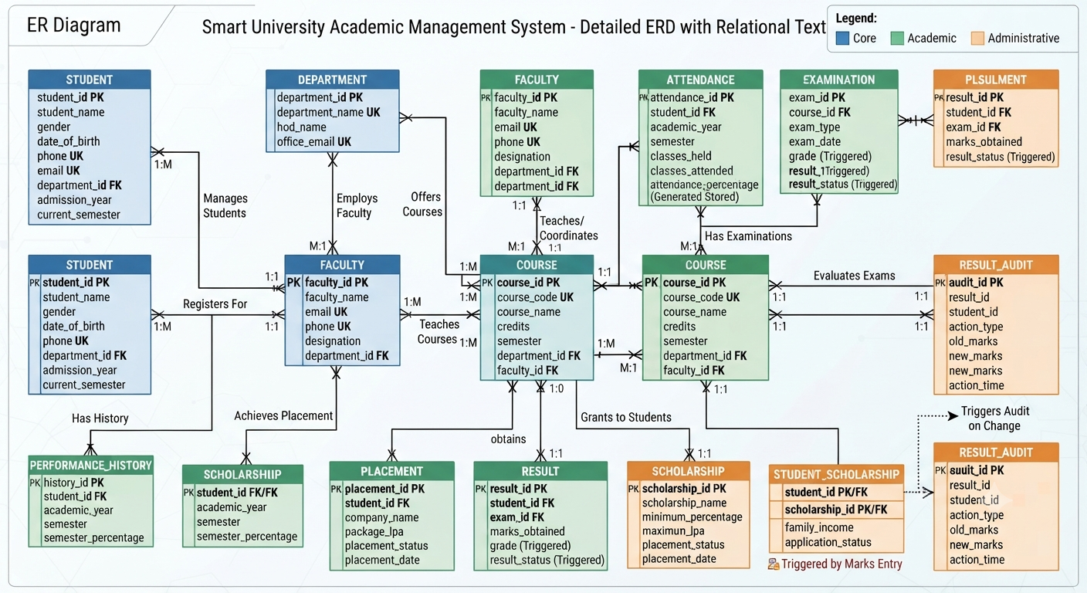

In the diagram, rectangles represent entities, ellipses represent attributes (with double ellipses for multi-valued attributes such as multiple phone numbers, and dashed ellipses for derived attributes such as GPA), and diamonds represent relationships, with crow's-foot notation marking cardinality on each connecting line, consistent with the relationships listed in Section 5.3. The system centers on the STUDENT entity, which contains attributes for personal and academic data, and participates in several key relationships: Manages Students with DEPARTMENT (1:M), Registers For with COURSE (M:M), Has History with PERFORMANCE_HISTORY (1:M), Achieves Placement with PLACEMENT (1:M), obtains with RESULT (1:M), and Grants to Students with SCHOLARSHIP (1:M). The DEPARTMENT entity also connects to FACULTY via Employs Faculty (1:M), and Offers Courses with COURSE (1:M). Further academic interdependencies are shown where FACULTY Teaches/Coordinates COURSE (1:M), COURSE has Has Examinations (1:M) with EXAMINATION, and EXAMINATION is related via Evaluates Exams (1:M) to RESULT, which subsequently Triggers Audit on Change (1:1) with RESULT_AUDIT. Additional tables include ATTENDANCE for tracking student records, STUDENT_SCHOLARSHIP for application details, and PLACEMENT and SCHOLARSHIP tables that maintain specific program information. The legend indicates color-coding for Core (Blue), Academic (Green), and Administrative (Orange) entities.

5.5 Relational Schema

The ER diagram of the Smart University Academic Management System is converted into the following relational schema. Primary keys are shown in bold, and foreign keys are marked with *.

Department (Dept_ID, Dept_Name, HOD_Name)

Student (Student_ID, Student_Name, Department_ID*, Semester, Email, Phone, Admission_Year)

Faculty (Faculty_ID, Faculty_Name, Designation, Department_ID*, Email, Phone)

Course (Course_ID, Course_Name, Credits, Department_ID*, Faculty_ID*)

Enrollment (Enrollment_ID, Student_ID*, Course_ID*, Academic_Year, Semester, Enrollment_Date)

Attendance (Attendance_ID, Student_ID*, Course_ID*, Classes_Held, Classes_Attended, Attendance_Percentage)

Examination (Exam_ID, Course_ID*, Exam_Name, Exam_Date, Max_Marks)

Result (Result_ID, Student_ID*, Exam_ID*, Marks_Obtained, Grade, Status)

Placement (Placement_ID, Student_ID*, Company_Name, Job_Role, Package_LPA, Placement_Date, Status)

Scholarship (Scholarship_ID, Scholarship_Name, Provider, Amount, Eligibility_Criteria)

Student_Scholarship (Student_ID*, Scholarship_ID*, Awarded_Date, Academic_Year)

Performance_History (History_ID, Student_ID*, Semester, Semester_GPA, Backlogs, Attendance_Percentage, Performance_Status)

Result_Audit (Audit_ID, Result_ID, Student_ID, Old_Marks, New_Marks, Old_Grade, New_Grade, Action_Type, Changed_At)

(*) denotes a foreign key referencing the primary key of the related table.The schema provides a structured representation of university departments, students, faculty, courses, enrolment, attendance, examinations, results, placements, scholarships, performance history, and result auditing.

5.6 Primary Keys and Foreign Keys
Primary keys uniquely identify records in a table, while foreign keys establish relationships between related tables and maintain referential integrity. MySQL foreign-key constraints are used to cross-reference related records and maintain consistency.
Table. 5.4: Primary Keys and Foreign Keys of Entities
Table | Primary Key | Foreign Key(s) and Reference
Department | Dept_ID | —
Student | Student_ID | Dept_ID → Department
Faculty | Faculty_ID | Dept_ID → Department
Course | Course_ID | Department_ID → Department; Faculty_ID → Faculty
Enrolment | Enrolment_ID, | Student_ID → Student; Course_ID → Course
Attendance | Attendance_ID | Student_ID → Student; Course_ID → Course
Examination | Exam_ID | Course_ID → Course
Result | Result_ID | Student_ID → Student; Exam_ID → Examination
Placement | Placement_ID | Student_ID → Student
Scholarship | Scholarship _ID | —
Performance_History | History_ID | Student_ID → Student
Result_Audit | Audit_ID | Result_ID, Student_ID
Student_ Scholarship | Student_ID, Scholarship_ID | Student_ID → Student; Scholarship_ID → Scholarship

The Student_Scholarship table uses a composite primary key because it represents the relationship between students and scholarships.

5.7 Normalization

Normalization is the process of organizing data into related tables to reduce redundancy and prevent insertion, update, and deletion anomalies. The Smart University Academic Management System is designed up to Third Normal Form (3NF).Student, department, faculty, course, enrolment, attendance, examination, and result information are maintained in separate relations. This avoids unnecessary duplication and improves data consistency.

5.8 First Normal Form (1NF)

A relation is in 1NF when every attribute contains a single atomic value and there are no repeating groups.

For example, storing multiple courses in one Student record would violate 1NF:

Student(Student_ID, Student_Name, Courses)

Example:

101, Amrutha, {DBMS, AI, Python}

To satisfy 1NF, course enrolment is stored separately:

Student(Student_ID, Student_Name, ...)

Enrollment(Enrollment_ID, Student_ID, Course_ID, Semester, Academic_Year)

Thus, each enrollment record contains one student-course association and all attributes contain atomic values.

5.9 Second Normal Form (2NF)

A relation is in 2NF when it is in 1NF and every non-key attribute is fully dependent on the complete primary key.This is particularly important for the many-to-many relationship between students and scholarships. Student details and scholarship details should not be repeated in the relationship table.Therefore, the information is separated into:

Student(Student_ID, Student_Name, ...)

Scholarship(Scholarship_ID, Scholarship_Name, Amount, ...)

Student_Scholarship(Student_ID, Scholarship_ID, Awarded_Date, Academic_Year)

This removes partial dependencies and avoids unnecessary repetition.

5.10 Third Normal Form (3NF)
A relation is in 3NF when it is in 2NF and contains no transitive dependencies.
For example, storing department details directly in the Student table can create the dependency:
Student_ID → Department_ID → Department_Name
To remove this transitive dependency, department information is stored separately:
Department(Dept_ID, Dept_Name, HOD_Name)
Student(Student_ID, Student_Name, Dept_ID, ...)
The Student table therefore stores only Dept_ID as a foreign key.
Similarly, faculty, course, examination, and other academic information are maintained in separate related tables. This ensures that non-key attributes depend on the appropriate primary key rather than on other non-key attributes.

5.11 Data Integrity and Constraints

The Smart University Academic Management System uses the following integrity constraints:

Entity Integrity: Primary keys uniquely identify every record and cannot contain NULL values.

Referential Integrity: Foreign keys ensure that related records exist in the referenced tables.

Domain Integrity: Data types and CHECK constraints restrict values to valid ranges.

NOT NULL: Mandatory attributes such as student name, course name, and examination details are prevented from being left empty.

UNIQUE: Fields such as student or faculty email can be restricted from having duplicate values.

DEFAULT: Suitable default values can be provided for fields such as status.

CHECK: Values such as marks, credits, attendance, and package amounts can be restricted to valid ranges.

Triggers: Result modifications can be automatically recorded in the Result_Audit table.

Functions and Procedures: Academic risk assessment and placement eligibility are supported through database functions and procedures.

These constraints help maintain accurate, consistent, and reliable academic records.

5.12 Summary
This chapter presented the relational design of the Smart University Academic Management System. The ER model was converted into a relational schema consisting of tables for departments, students, faculty, courses, enrolment, attendance, examinations, results, placements, scholarships, performance history, and result auditing.
Primary keys and foreign keys were defined to establish relationships and maintain referential integrity. The database was normalized through 1NF, 2NF, and 3NF to reduce redundancy and eliminate partial and transitive dependencies.
Integrity constraints, triggers, functions, and procedures further support reliable academic data management, risk assessment, placement eligibility, and result auditing. The resulting schema provides the foundation for the SQL implementation presented in the next chapter.

CHAPTER 6 SQL OPERATIONS AND QUERIES

6.1 Introduction

This chapter presents the implementation of the relational schema designed in Chapter 5 using MySQL. It demonstrates various SQL operations performed on the smart university database, including database and table creation, data insertion, data retrieval, data modification, deletion, joins, aggregate functions, subqueries, views, functions, procedures, and triggers.All SQL statements use the same table and column names defined in the relational schema to maintain consistency between the database design and its implementation.

6.2 Database and Table Creation

The smart_university database is created first, followed by the creation of the individual tables. The tables are created in an order that respects their foreign-key dependencies. Parent tables such as Department, Student, Faculty, and Scholarship are created before dependent tables such as Course, Enrolment, Attendance, Examination, Result, Placement, Student_Scholarship, and Performance_History.
CREATE DATABASE smart_university;
USE smart_university;
/* =========================================================
2. DEPARTMENT TABLE
========================================================= */
CREATE TABLE department (
department_id INT PRIMARY KEY AUTO_INCREMENT,
department_name VARCHAR(100) NOT NULL UNIQUE,
hod_name VARCHAR(100),
office_email VARCHAR(100) UNIQUE
);
/* =========================================================
3. STUDENT TABLE
========================================================= */
CREATE TABLE student (
student_id INT PRIMARY KEY,
student_name VARCHAR(100) NOT NULL,
gender VARCHAR(10),
date_of_birth DATE,
phone VARCHAR(15) UNIQUE,
email VARCHAR(100) UNIQUE,
department_id INT NOT NULL,
admission_year YEAR NOT NULL,
current_semester INT NOT NULL,
CONSTRAINT fk_student_department
FOREIGN KEY (department_id)
REFERENCES department(department_id),
CONSTRAINT chk_student_semester
CHECK (current_semester BETWEEN 1 AND 8)
);
/* =========================================================
4. FACULTY TABLE
========================================================= */
CREATE TABLE faculty (
faculty_id INT PRIMARY KEY AUTO_INCREMENT,
faculty_name VARCHAR(100) NOT NULL,
email VARCHAR(100) UNIQUE,
phone VARCHAR(15) UNIQUE,
designation VARCHAR(50),
department_id INT NOT NULL,
CONSTRAINT fk_faculty_department
FOREIGN KEY (department_id)
REFERENCES department(department_id)
);
/* =========================================================
5. COURSE TABLE
========================================================= */
CREATE TABLE course (
course_id INT PRIMARY KEY AUTO_INCREMENT,
course_code VARCHAR(20) NOT NULL UNIQUE,
course_name VARCHAR(100) NOT NULL,
credits INT NOT NULL,
semester INT NOT NULL,
department_id INT NOT NULL,
faculty_id INT,
CONSTRAINT fk_course_department
FOREIGN KEY (department_id)
REFERENCES department(department_id),
CONSTRAINT fk_course_faculty
FOREIGN KEY (faculty_id)
REFERENCES faculty(faculty_id),
CONSTRAINT chk_course_credits
CHECK (credits BETWEEN 1 AND 10),
CONSTRAINT chk_course_semester
CHECK (semester BETWEEN 1 AND 8)
);
/* =========================================================
6. ENROLLMENT TABLE
========================================================= */
CREATE TABLE enrolment (
enrolment_id INT PRIMARY KEY AUTO_INCREMENT,
student_id INT NOT NULL,
course_id INT NOT NULL,
academic_year VARCHAR(20) NOT NULL,
semester INT NOT NULL,
enrollment_date DATE NOT NULL,
CONSTRAINT fk_enrollment_student
FOREIGN KEY (student_id)
REFERENCES student(student_id),

CONSTRAINT fk_enrollment_course
FOREIGN KEY (course_id)
REFERENCES course(course_id),
CONSTRAINT chk_enrollment_semester
CHECK (semester BETWEEN 1 AND 8),
CONSTRAINT uq_student_course
UNIQUE(student_id, course_id, academic_year)
);

6.3 Data Insertion

Sample records were inserted into the database to populate the tables and test the relationships, constraints, and SQL operations. The records were inserted in an appropriate order so that the required department and student records were available before inserting related academic records.

Sample INSERT Statements

INSERT INTO department

(department_name, hod_name, office_email)

VALUES

('AIML', 'Dr. Ravi Kumar', 'aiml@university.edu'),

('CSE', 'Dr. Suresh Rao', 'cse@university.edu'),

('ECE', 'Dr. Anil Kumar', 'ece@university.edu'),

('IT', 'Dr. Lakshmi Devi', 'it@university.edu');

INSERT INTO student

(student_id, student_name, gender, department_id, admission_year, current_semester)

VALUES

(101, 'Amrutha', 'Female', 1, 2024, 3),

(102, 'Rahul', 'Male', 2, 2024, 3),

(103, 'Sneha', 'Female', 1, 2024, 3);

INSERT INTO course

(course_code, course_name, credits, semester, department_id)

VALUES

('AI301', 'Artificial Intelligence', 4, 3, 1),

('ML301', 'Machine Learning', 4, 3, 1),

('DB301', 'Database Management Systems', 4, 3, 1);

INSERT INTO enrollment

(student_id, course_id, academic_year, semester, enrollment_date)

VALUES

(101, 1, '2026-27', 3, '2026-07-01'),

(101, 2, '2026-27', 3, '2026-07-01'),

(102, 1, '2026-27', 3, '2026-07-01');

Similar sample records were inserted into the Faculty, Attendance, Examination, Result, Placement, Scholarship, Student_Scholarship, Performance_History, and Result_Audit tables for testing and demonstration.

6.4 Data Retrieval

SELECT statements are used to retrieve and display academic information stored in the Smart University Academic Management System. The following queries demonstrate basic data retrieval from the main tables.

SELECT * FROM department;

SELECT * FROM student;

SELECT * FROM faculty;

SELECT * FROM course;

SELECT * FROM enrollment;

SELECT * FROM attendance;

SELECT * FROM examination;

SELECT * FROM result;

These queries retrieve the stored records from the respective tables and are useful for verifying the inserted data and database structure. Similar SELECT operations can be performed on the placement, scholarship, student_scholarship, performance_history, and result_audit tables.

6.5 Data Modification

UPDATE statements are used to modify existing academic records in the Smart University Academic Management System. They can be used to update student information, course details, attendance records, placement status, and scholarship application status.

UPDATE Student

SET Phone = '9876543210'

WHERE Student_ID = 101;

UPDATE Course

SET Credits = 4

WHERE Course_ID = 1;

UPDATE Attendance

SET Classes_Attended = Classes_Attended + 1

WHERE Student_ID = 101

AND Course_ID = 1;

UPDATE Placement

SET Placement_Status = 'Placed'

WHERE Placement_ID = 1;

These operations allow authorized users to maintain accurate and up-to-date academic information in the database.

6.6 Data Deletion
DELETE statements remove records that are no longer needed, such as cancelling an Enrolment:
DELETE FROM Enrollment WHERE Enrollment_ID = 6;

6.7 Joins

Joins are used to combine related data from two or more tables using common columns. In the Smart University Academic Management System, joins are useful for generating reports that require information from students, departments, courses, enrollment, attendance, and results.

INNER JOIN

INNER JOIN returns only the records that have matching values in both tables. It can be used to display students along with their department details.

SELECT S.Student_ID,

S.Name AS Student_Name,

D.Name AS Department_Name

FROM Student S

INNER JOIN Department D

ON S.Department_ID = D.Department_ID;

The following query combines Student, Enrollment, and Course tables to display the courses registered by students.

SELECT S.Student_ID,

S.Name AS Student_Name,

C.Course_Name,

E.Semester

FROM Student S

INNER JOIN Enrollment E

ON S.Student_ID = E.Student_ID

INNER JOIN Course C

ON E.Course_ID = C.Course_ID;

LEFT JOIN

LEFT JOIN returns all records from the left table and the matching records from the right table. If there is no matching record, NULL is displayed.

SELECT D.Department_ID,

D.Name AS Department_Name,

F.Name AS Faculty_Name

FROM Department D

LEFT JOIN Faculty F

ON D.Department_ID = F.Department_ID;

This query displays all departments, including departments that do not have a corresponding faculty record.

RIGHT JOIN

RIGHT JOIN returns all records from the right table along with matching records from the left table.

SELECT D.Name AS Department_Name,

F.Name AS Faculty_Name

FROM Faculty F

RIGHT JOIN Department D

ON F.Department_ID = D.Department_ID;

SELF JOIN

A SELF JOIN joins a table with itself. It can be used to compare students belonging to the same department.

SELECT S1.Name AS Student_1,

S2.Name AS Student_2,

S1.Department_ID

FROM Student S1

JOIN Student S2

ON S1.Department_ID = S2.Department_ID

AND S1.Student_ID < S2.Student_ID;

Joins help the system retrieve meaningful information from multiple related tables while maintaining the normalized structure of the database.

6.8 Aggregate Functions

Aggregate functions perform calculations on a group of records and return a single value. In the Smart University Academic Management System, functions such as COUNT(), SUM(), AVG(), MAX(), and MIN() are used to analyze students, enrollments, marks, and academic performance.

COUNT() – Number of Students

SELECT COUNT(*) AS Total_Students

FROM Student;

COUNT() – Number of Courses

SELECT COUNT(*) AS Total_Courses

FROM Course;

COUNT() – Number of Enrollments

SELECT COUNT(*) AS Total_Enrollments

FROM Enrollment;

AVG() – Average Marks

SELECT AVG(Marks) AS Average_Marks

FROM Result;

MAX() – Highest Marks

SELECT MAX(Marks) AS Highest_Marks

FROM Result;

MIN() – Lowest Marks

SELECT MIN(Marks) AS Lowest_Marks

FROM Result;

SUM() – Total Scholarship Amount

SELECT SUM(Amount) AS Total_Scholarship_Amount

FROM Scholarship;

These aggregate functions help the university analyse the overall size of the student database, course enrolment, academic performance, and scholarship distribution efficiently.

6.9 Subqueries

Subqueries are queries written inside another SQL query. They are useful for answering questions that require the result of one query to be used by another query. In the Smart University Academic Management System, subqueries can be used to identify students with above-average marks, students with the highest marks, and courses with higher enrollment.

Students Having Marks Greater Than Average

SELECT S.Student_ID, S.Name, R.Marks

FROM Student S

JOIN Result R

ON S.Student_ID = R.Student_ID

WHERE R.Marks >

(

SELECT AVG(Marks)

FROM Result

);

Student Having the Highest Marks

SELECT S.Student_ID, S.Name, R.Marks

FROM Student S

JOIN Result R

ON S.Student_ID = R.Student_ID

WHERE R.Marks =

(

SELECT MAX(Marks)

FROM Result

);

Students Having Attendance Above Average

SELECT S.Student_ID, S.Name, A.Attendance_Percentage

FROM Student S

JOIN Attendance A

ON S.Student_ID = A.Student_ID

WHERE A.Attendance_Percentage >

(

SELECT AVG(Attendance_Percentage)

FROM Attendance

);

These subqueries help perform academic analysis by comparing individual student records with calculated values such as average and maximum marks or attendance.

6.10 Views
Views are virtual tables created from one or more tables. They simplify frequently used queries and provide organized access to required information without duplicating the original data.
STUDENT VIEW
CREATE VIEW Student_Report AS
SELECT Student_ID, Name, Department_ID, Semester
FROM Student;
SELECT * FROM Student_Report;
FACULTY VIEW
CREATE VIEW Faculty_Report AS
SELECT F.Faculty_ID,
F.Name AS Faculty_Name,
F.Department_ID,
D.Name AS Department_Name
FROM Faculty F
LEFT JOIN Department D
ON F.Department_ID = D.Department_ID;
SELECT * FROM Faculty_Report;
This view displays faculty details along with their departments.
STUDENT RESULT VIEW
CREATE VIEW Student_Result_Report AS
SELECT S.Student_ID,
S.Name AS Student_Name,
R.Marks,
R.Grade,
R.Status
FROM Student S
JOIN Result R
ON S.Student_ID = R.Student_ID;
SELECT * FROM Student_Result_Report;
This view provides a simple report of students and their academic results.

CHAPTER 7 RESULTS AND ANALYSIS

7.1 Introduction

This chapter presents the results obtained from implementing the Smart University Academic Management System database in MySQL and executing the SQL operations described in Chapter 6. The results demonstrate the successful implementation of the relational database, data retrieval and modification operations, table relationships, constraints, views, functions, triggers, and academic reporting features. The outputs are based on the sample data inserted into the smart_university database and are intended to demonstrate the functionality and correctness of the proposed database system.

7.2 Database Implementation

The smart_university database was implemented using thirteen tables — Department, Student, Faculty, Course, Enrollment, Attendance, Examination, Result, Placement, Scholarship, Student_Scholarship, Performance_History, and Result_Audit. The tables were created according to the relational schema defined in the previous chapters, with primary keys and foreign keys establishing the required relationships among academic, student, examination, attendance, placement, and scholarship data.

7.3 Table Creation and Data Insertion

The tables of the Smart University Academic Management System were created using the SQL CREATE TABLE statements described in Chapter 6. Appropriate primary keys, foreign keys, NOT NULL, UNIQUE, CHECK, and DEFAULT constraints were applied according to the database design.Sample records were inserted into the Department, Student, Faculty, Course, Enrollment, Attendance, Examination, Result, Placement, Scholarship, Student_Scholarship, Performance_History, and Result_Audit tables.The successful insertion of related records demonstrates that the database relationships are functioning correctly. Foreign-key constraints prevent the insertion of records that reference non-existent parent records, thereby maintaining referential integrity between related tables.

7.4 SQL Query Results

The SQL queries presented in Chapter 6 were executed against the smart_university database to verify data retrieval and analysis operations.

The main results include:

Student retrieval queries successfully display student details based on specified conditions.

Course and enrolment queries retrieve information about courses registered by students.

JOIN queries combine information from related tables such as Student, Department, Course, Enrolment, Faculty, and Result.

Aggregate queries calculate values such as counts, averages, and other summary information from academic records.

GROUP BY and HAVING queries provide grouped academic information and allow groups to be filtered according to specified conditions.

Subqueries retrieve records based on calculated or related values from other queries.

Attendance-related queries provide academic attendance information and support identification of students requiring attention.

Placement-related queries identify students according to placement eligibility conditions.

Academic risk-related queries provide calculated information about students' academic performance and risk levels.

These operations demonstrate that the database can support both basic data retrieval and analytical academic queries.

7.5 Relationship Analysis

The relationships between the database entities were verified through queries involving multiple related tables A student can be associated with a department and can enrol in multiple courses through the Enrolment table. Attendance records are associated with students and courses, while examination and result records provide information about academic performance.

The Result table connects examination-related information with student academic performance. Placement information is associated with eligible students, while scholarship information is connected to students through the Student_Scholarship relationship.The Performance_History table maintains historical academic information, and the Result_Audit table records relevant result-related changes.These relationships allow academic information to be retrieved across multiple tables without unnecessary duplication of data

7.6 Constraint Validation

The database constraints were implemented to maintain the accuracy and consistency of academic records . Primary-key constraints ensure that every record has a unique identifier. Foreign-key constraints maintain valid relationships between related tables. NOT NULL constraints ensure that required information is provided, while UNIQUE constraints prevent duplicate values where uniqueness is required . CHECK constraints restrict values to valid ranges or permitted conditions, and DEFAULT constraints automatically provide predefined values when applicable.The constraints therefore provide database-level validation and help prevent inconsistent or invalid academic records.

7.7 Key Findings

A thirteen-table, foreign-key-linked relational schema is sufficient to model the core academic operations of a university — student management, department management, faculty, courses, enrollment, attendance, examinations, results, placements, scholarships, and academic performance — while reducing unnecessary data duplication.
• Applying 1NF, 2NF, and 3NF during database design (Chapter 5) helps minimize data redundancy and prevents common modification anomalies by separating student, department, course, faculty, enrolment, examination, and result information into appropriately related tables.
• Database-level constraints such as PRIMARY KEY, FOREIGN KEY, NOT NULL, UNIQUE, CHECK, and DEFAULT help maintain data integrity and ensure that invalid or inconsistent academic records are restricted at the database level.
• Views provide a practical way to present commonly required academic information in a structured form without repeatedly writing complex queries or directly exposing all underlying table structures.
• Database functions such as calculate_risk() and placement_eligibility() support automated academic analysis, while the corresponding reports provide useful information for identifying academic risk and evaluating placement eligibility.
• Triggers and the Result_Audit mechanism support automatic result-related processing and improve the traceability of changes made to academic result information.
• The database design can be extended to different university and academic environments because its core structure focuses on general academic processes rather than institution-specific operational requirements.

CHAPTER 8 OUTPUT SCREENS
This chapter presents the output screens captured during the implementation and testing of the Smart University Academic Management System database in MySQL Workbench. The screenshots demonstrate the successful execution of database creation, table operations, data retrieval, SQL queries, academic reports, functions, triggers, and other database operations implemented in the project. Each figure should be replaced with the corresponding actual screenshot captured from MySQL Workbench during implementation and testing.
Figure 8.1: MySQL Database Creation
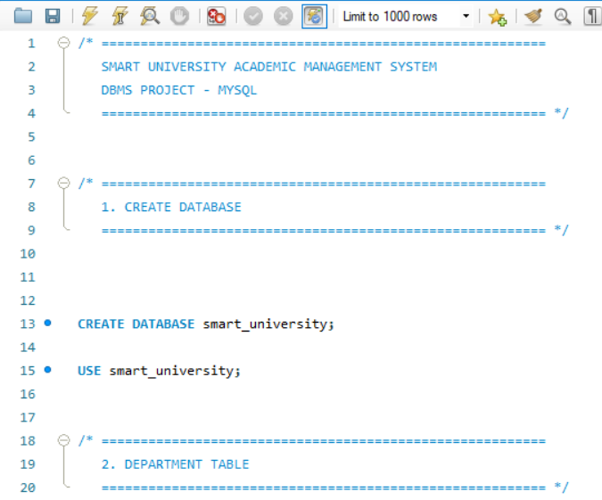
Figure 8.2: Student , Department , Faculty Tables
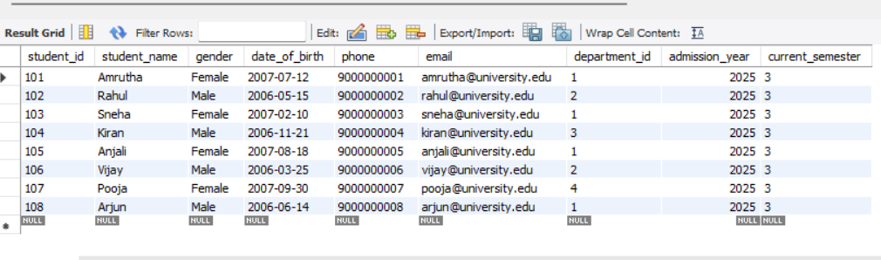
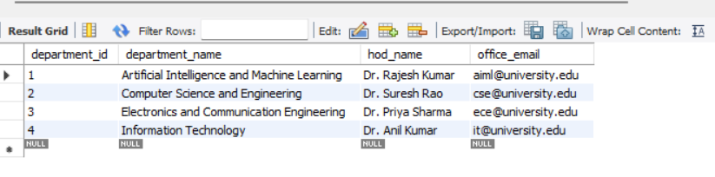
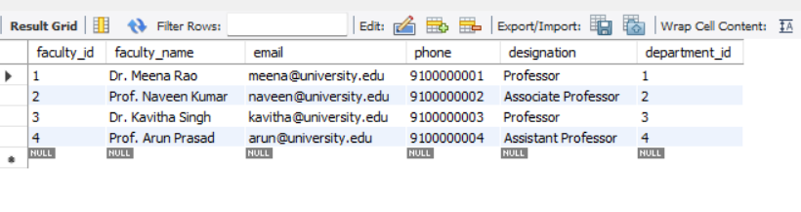
Figure 8.3: Course, Enrolment Tables
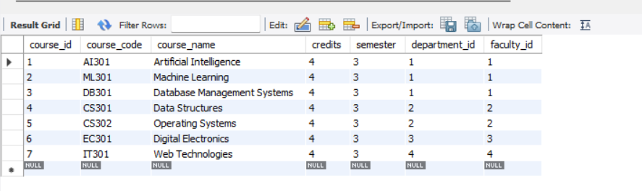
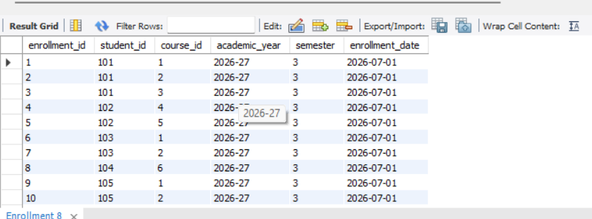
Figure 8.4: Attendance , ExaminationTables
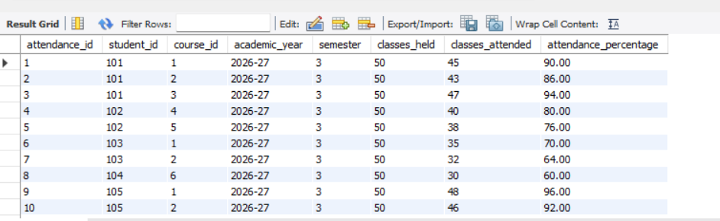
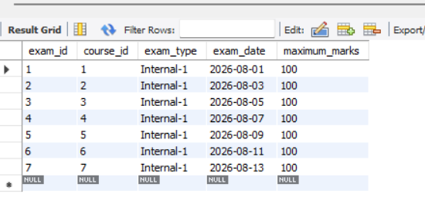
Figure 8.5: Result , Placement Tables
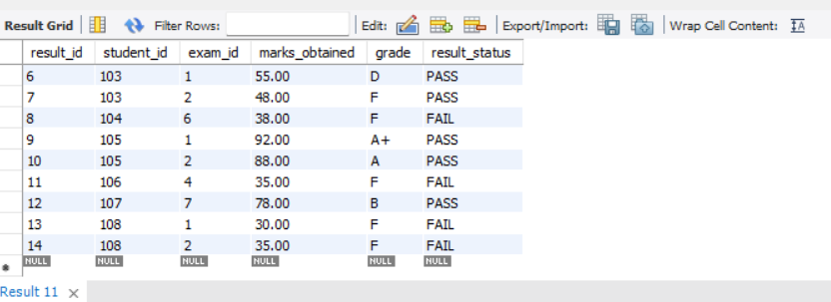
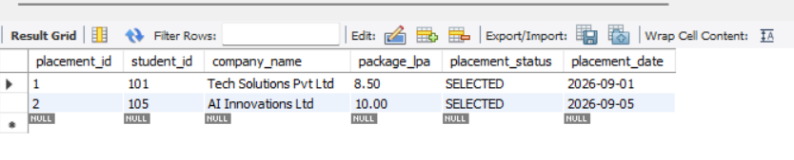
Figure 8.6: Scholarship & Student scholarship Tables
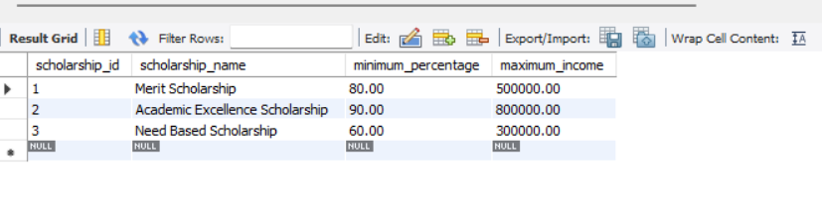
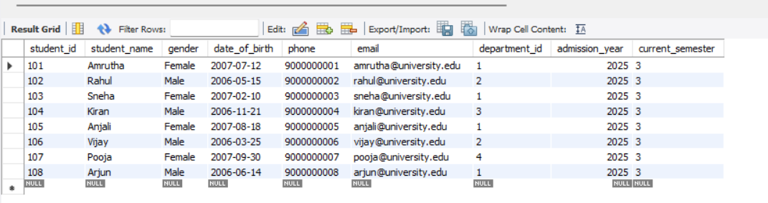
Figure 8.7: Performance History & result audit Tables
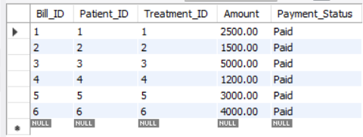
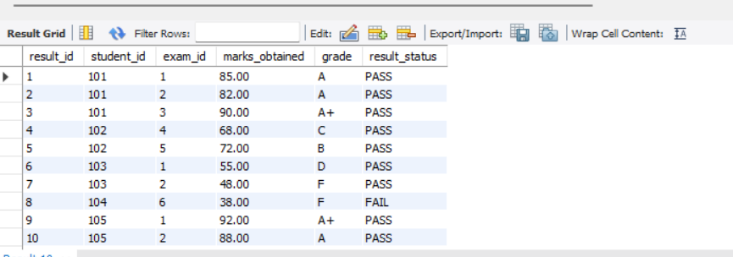
Figure 8.8: Sample SQL Query Output
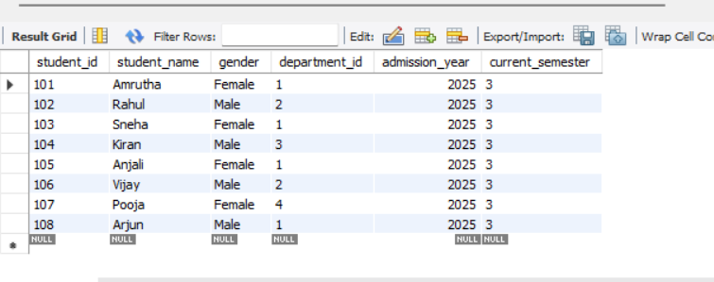
Figure 8.9: JOIN Query Output
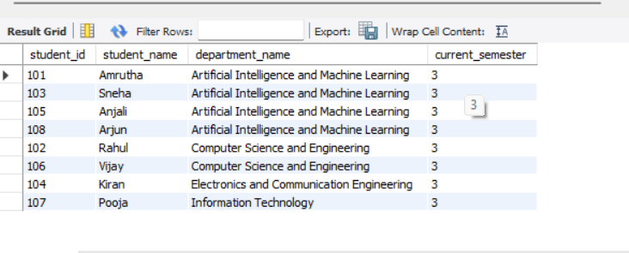

Figure 8.10: Aggregate Query Output
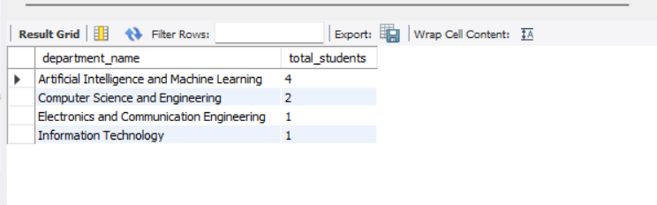
Figure 8.11: Academic Risk Report Output
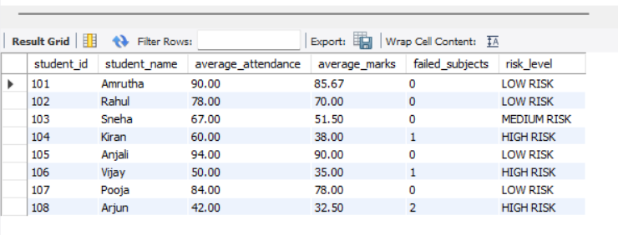
Figure 8.12: Placement Eligibility Report Output
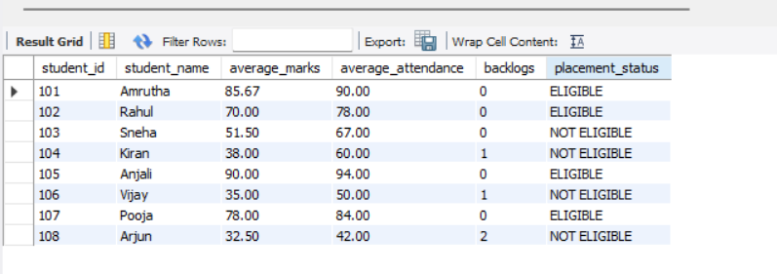

Figure 8.13: Student Academic Summary Output
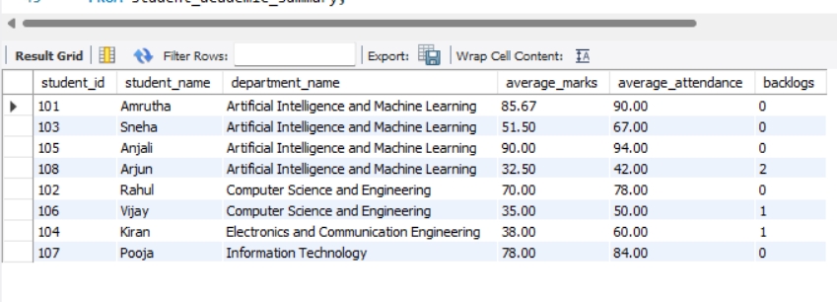
Figure 8.14: Department Performance Output
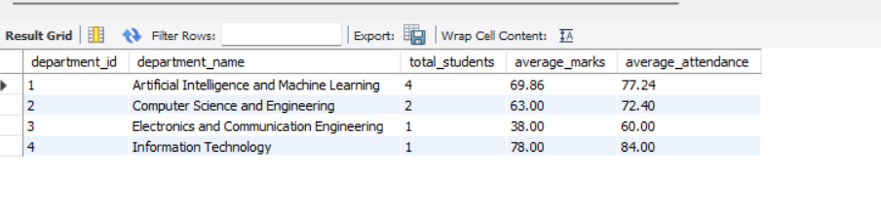

CONCLUSION
The Smart University Academic Management System successfully provides a centralized relational database for managing important academic activities such as student records, departments, faculty, courses, enrolment, attendance, examinations, results, scholarships, and placements. The database is designed using normalized tables and well-defined relationships to reduce data redundancy and maintain data consistency.
The project demonstrates various SQL operations including INSERT, SELECT, UPDATE, DELETE, JOINs, aggregate functions, subqueries, and views. It also implements advanced database features such as functions, triggers, stored procedures, and indexes. The academic risk and placement eligibility reports provide useful information for monitoring student performance and supporting academic and placement-related activities.
Overall, the system provides a reliable and organized database foundation for university academic management. It improves data integrity, simplifies information retrieval, and can be further extended with application interfaces, dashboards, notifications, and intelligent analytics.

FUTURE SCOPE
Although the current project provides a normalized and functional database for university academic management, several enhancements can be introduced in the future to improve its usability, automation, and scalability:
- Student Portal: A web-based portal can allow students to view attendance, examination results, course details, academic performance, scholarships, and placement status.
- Faculty Portal: Faculty members can be provided with an interface to manage attendance, course information, examination marks, and student performance records.
- Role-Based Access Control: Different access permissions can be provided for students, faculty, administrators, and placement officers to improve security and protect academic information.
- Automated Notifications: The system can send notifications for low attendance, examination schedules, result updates, scholarship applications, and placement activities through email or SMS.
- Performance Analytics: Dashboards and visual reports can be developed to analyze student performance, attendance trends, department performance, and academic risk levels.
- Predictive Analytics: Machine learning techniques can be integrated to predict students who may be academically at risk and provide early support based on attendance and performance history.
- Online Examination Integration: The system can be extended to support online examinations, automated evaluation, and direct storage of examination results.
- Cloud Deployment: The database can be deployed on a cloud platform to provide better availability, backup, scalability, and secure access from different locations.
- Mobile Application: A mobile application can be developed to provide students and faculty with convenient access to academic information and notifications.
These enhancements can transform the current database into a complete and intelligent university management platform while providing greater automation, accessibility, and data-driven academic support.
These enhancements would be layered on top of the existing normalized schema without requiring structural changes to the core entities designed in Chapter 5

REFERENCES
- Elmasri, R., & Navathe, S. B., Fundamentals of Database Systems, 7th Edition, Pearson Education, 2017.
- Silberschatz, A., Korth, H. F., & Sudarshan, S., Database System Concepts, 7th Edition, McGraw-Hill Education, 2019.
- Date, C. J., An Introduction to Database Systems, 8th Edition, Pearson Education, 2003.
- Oracle Corporation, MySQL 8.0 Reference Manual. Available at: MySQL Documentation
- Oracle Corporation, MySQL Workbench Documentation. Available at: MySQL Workbench Documentation
- Codd, E. F., “A Relational Model of Data for Large Shared Data Banks,” Communications of the ACM, Vol. 13, No. 6, pp. 377–387, 1970.
- Chen, P. P., “The Entity-Relationship Model — Toward a Unified View of Data,” ACM Transactions on Database Systems, Vol. 1, No. 1, pp. 9–36, 1976.
- Kroenke, D. M., & Auer, D. J., Database Processing: Fundamentals, Design, and Implementation, 15th Edition, Pearson, 2018.

